

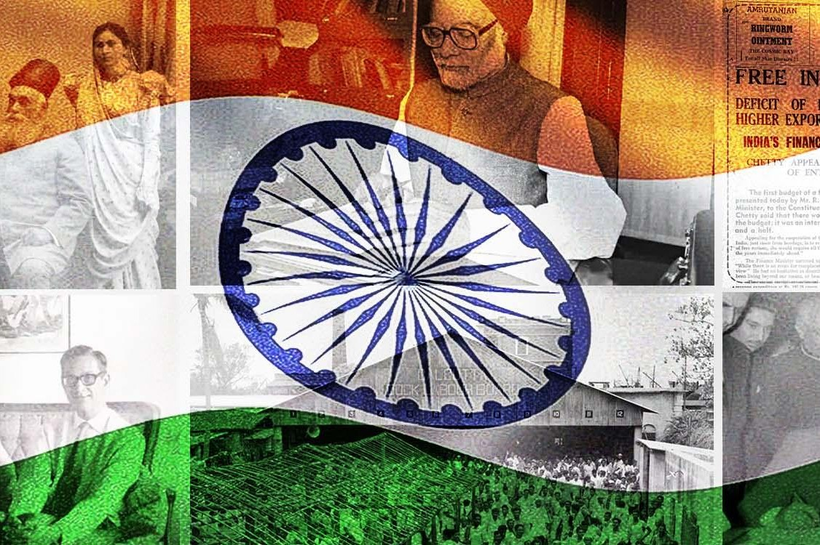

# GS1: Post-Independence History

June 2025

**Prepared together by:**

#### Madhav Agarwal (<https://t.me/madhavagrawalair16>)

#### Ratnesh Agrrwal (Insta: <https://www.instagram.com/ratnesh13/>)

**Disclaimer:** These notes are for guidance & reference only, based on our study, experience, & memory. Some fun mnemonics/terms may be included just to aid recall—no offence is intended. Please use your judgment and keep them updated over time.

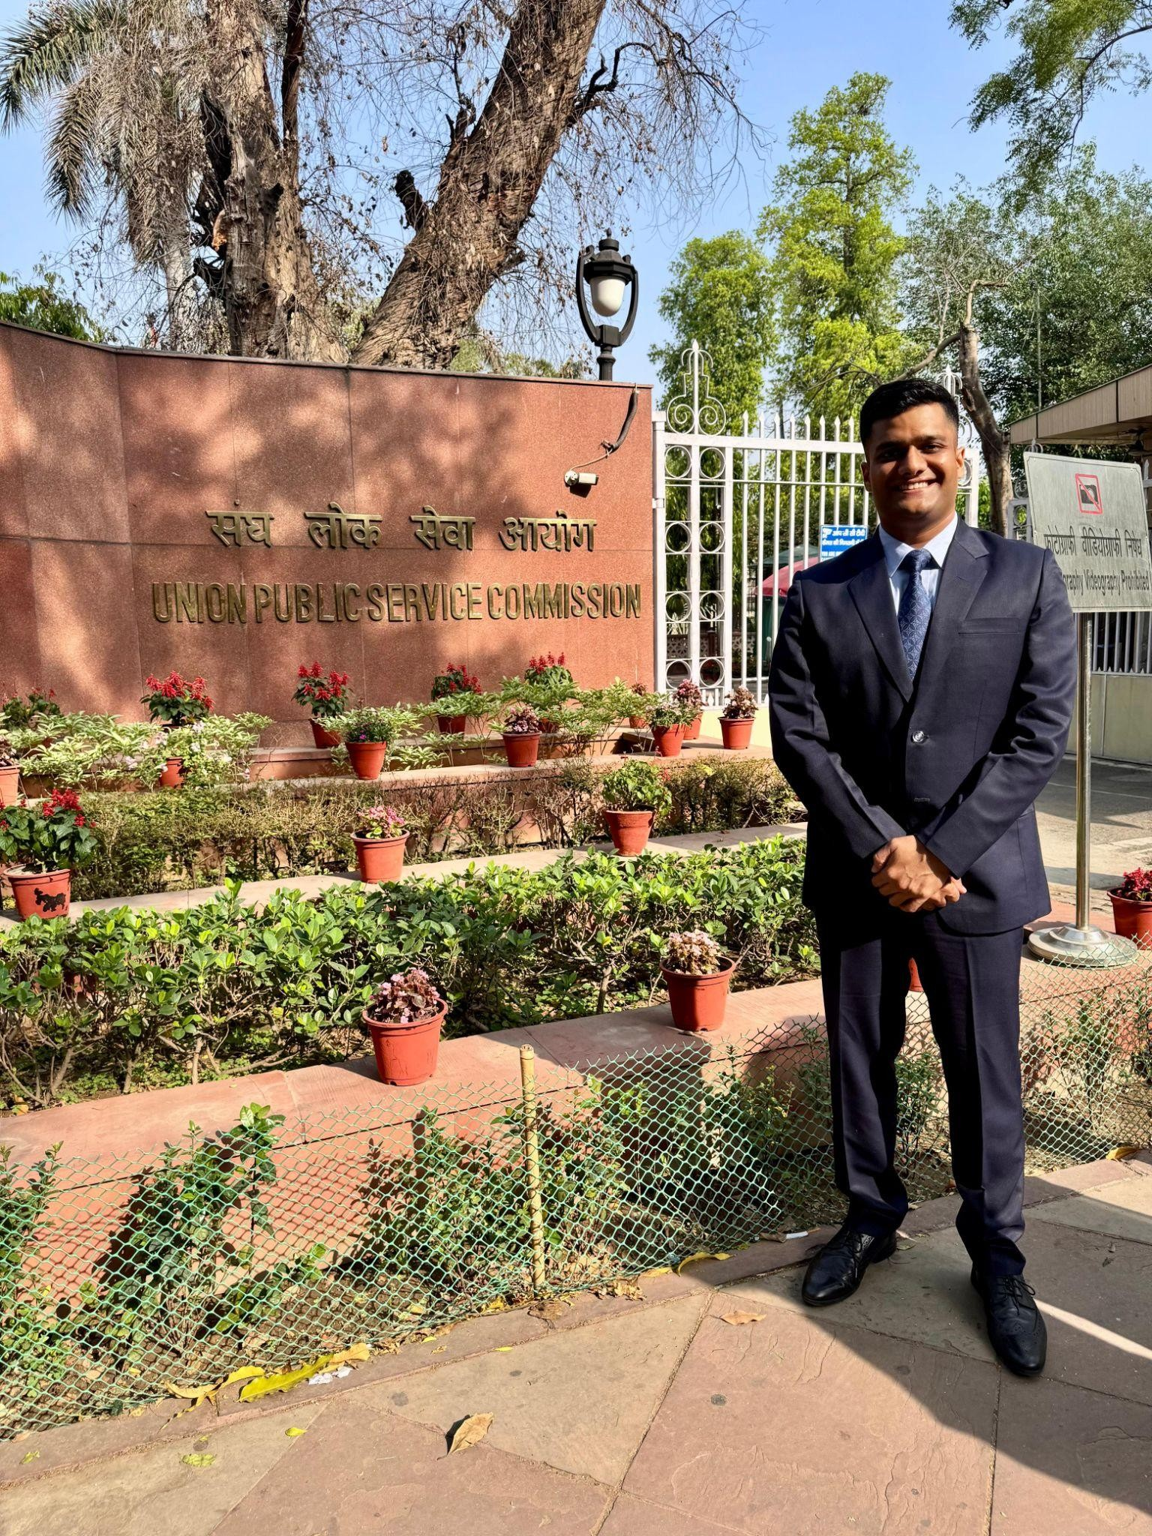**About Us**

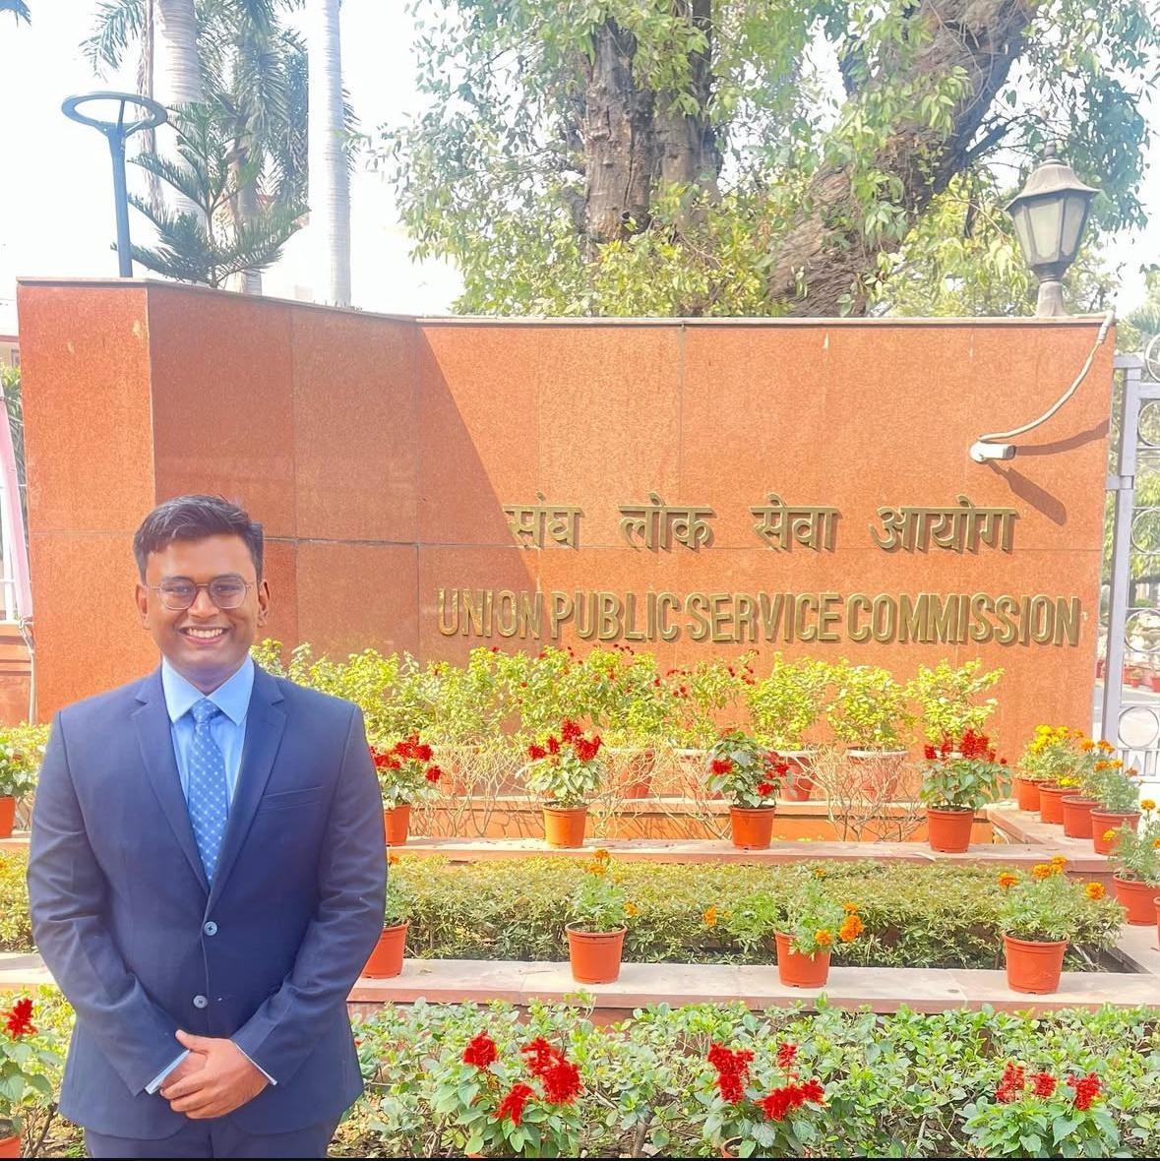

***Madhav Agarwal and Ratnesh Agrawal*** *— two friends, one mission, and a bond forged through shared dreams. From school classrooms to college corridors, their journey was always side by side. United by a common goal of cracking the UPSC, they spent over 300 hours on video calls — dissecting concepts, solving doubts, and building the notes that would become the backbone of their preparation.*

*Madhav went on to secure AIR 211 in CSE-2023 and then soared to* ***AIR 16 in CSE-2024****. Now set to join the* ***Indian Administrative Service****, he is living proof that quiet determination, when sustained with laser focus, can turn even the toughest dreams into destiny.*

*Ratnesh, who reached the* ***UPSC interview stage in CSE-2023****, chose a different but equally powerful path. With the same intensity and sharp thinking that marked his preparation, he stepped into the world of real estate. Today, he’s a* ***dynamic builder in Indore*** *— shaping skylines and lives with a vision rooted in public purpose and entrepreneurial fire.*

*These notes are a result of their shared struggle, deep friendship, and uncompromising pursuit of excellence — a* ***gift to future aspirants****, from two dreamers who refused to settle for average, each leaving a mark in his own way.*

**Index**

GS-1 Post Independence History 2

PYQs 2

Green Revolution 3

3 Challenges faced by India Post-Independence 5

Post-Independence Consolidation 5

Consolidation of territories from foreign govts 8

Privy Purse 8

Reorganization within the country 9

Bhoodan & Gramdan Movement: 10

Tashkent Agreement 1965 (Post India-Pakistan War of 1965) 12

Bangladesh War of Liberation 1971 13

Simla Agreement (SA) 1972 aka Suchetgarh Agreement 14

Planning & its impact 16

Punjab Crisis 18

Other themes from Test Series 20

#### **Notes**: These notes cover only select portions of Post-Independence History, as UPSC Mains PYQs have shown limited focus on this area. Instead of skipping it entirely, we chose to cover key themes. In later attempts, we also referred to Prahaar Summary PDFs (freely available) to reduce risk and ensure broader coverage.

**GS-1 Post Independence History**

### PYQs

1. 2022: The political and administrative reorganisation of states and territories has been a continuous ongoing process since the mid-nineteenth century. Discuss with examples (15m)
2. 2021: Assess the main administrative issues and socio-cultural problems in the integration process of Indian Princely States (10m) - covered below
3. 2014: The New Economic Policy – 1921 of Lenin had influenced the policies adopted by India soon after independence. Evaluate.
4. 2013: Evolution and significance of Jai Jawan, Jai Kisan
5. 2013: Contribution of Maulana Abdul Kalam Azad
6. 2013: Tashkent Agreement 1966 - Highlights
7. 2013: Compulsion which led India to play role in emergence of Bangladesh
8. 2013: Objectives and Success of Bhoodan and Graamdan movements
9. Older Questions
   1. 1997: How did Sardar Vallabhbhai Patel succeed in avoiding the evil consequences of the doctrine of lapse of paramountcy and in integrating Indian States?
   2. 1996: What was the role of the states people’s movement in the integration of Indian states?
   3. 1981: One of the outstanding achievements of the Government of independent India is the Integration of the former ‘Princely’ States with the Indian Union. How was this achieved? What important forces/factors helped the Unification of India?

## Green Revolution

* Conditions **before** GR
  + **Limited focus on technological base of agri** rather only institutional focus like Bhakra Nangal dam etc
  + Despite growth of 3% btw 49-65- **facing food shortages**- forced to import food from countries such as **US (PL-480 scheme) - ship to mouth**
    - **Two wars with China and Pak, succesive droughts in 65-66-** high prices as well arm twisting policies of US due to India’s stand on Vietanam affected imports

##### Jump in population growth, rise in per capita income → more demand

* + Govt **outlay on industralisation** put pressure on agri
  + **Zoning policy -** cannot supply food from one state to another resulted into **famine in Bihar**
* Initiatives prior to GR
  + Contrary to perception that agri total neglected- inv in massive irrigation and power projects like Bhakra nangal, agri uni etc (but limited regional impact)
* Introduction of GR
  + In 3 diff phases
    - 1st-60-70-‘s- inc in wheat yield in NW region of Punjab,Haryana, West UP
    - 2nd- 70-80-‘s- extension of HYV from wheat to rice, also further spread to UP,AP,Karnataka,TN, MH etc
    - 3rd -80’s-90’s- spread to low growth areas of Orissa, WB,MP, Raj
  + Govt measures: Assured Market -> **FCI , MSP , PDS , TPDS** and Food security laws, **Inst finance doubled**, **Agricultural Prices Commission (now called CACP)** set up for remunerative price to farmer, **better**

**credit**for new tech adoption; Pivotal role played by **MS Swaminathan**

* **Postive** impact of GR
  + **Food sufficiency**: Self sufficiency in food grains with marketable surplus, buffer stocks, also exporting
    - Liberation from US PL-480 (ship-to-mouth dependence on wheat aid)

##### Food Processing Industries also promoted post this

* + **Irrigated area**: Inc in gross irrigated area from 1mn hectares pre GR to

2.5 mn hectare post GR

* + **Employment**: Inc in emp in agri as well as non-agri rural and semi urban emp (agro allied industry, transport)
  + **Poverty reduced**: Inc consumption- demand for durables like radio, TV etc- impacted rural poverty
  + **PDS**: Govt provided PDS through surplus stocks
* **Negative** impact

##### Indian Agriculture is a victim of its own success - Eco Survey

* + Env impact of **excessive use of chemical fertilizers and pesticides**, excessive withdrawl of GW (eg: current **arsenic contaminations** in 13 districts of **Punjab; Cancer Train** PJ)
    - Distorted ratio of NPK

##### From 4:2:1 To 28:4:1

* + **Culture of subsidies, free electricity, guranteed procurement-** misuse of it- affected **fiscal deficit** till now; **Moral Hazard of loan waivers**
  + **Vandana Shiva -** argues that tech like Green Revol have **done more harm than good to land fertility**
  + **Class dispartity** b/w classes- **new middle class farmer (*Bullock capitalist*)**- politically influential **wheraes small tenant and**

**sharecroppers** suffered-**sowed the seeds of Left wing Extremism** due to inequality

* + - **NCERT:** The green revolution of 1960s had two effects. One is, the stark contrast between the poor peasantry and the landlords while the other is, **rise of the middle peasants section**
    - As resources were given to already irrigated areas of Punjab, Haryana along with guarantee of procurement for better start
    - However huge cost of HYV, pesticides etc for small farmers due to their small farm limited their growth
    - Landowners began to take back land from their tenants and cultivate it directly because cultivation was becoming more profitable
  + **Regional disparity**- Only certain regions such as the Punjab, western UP, coastal Andhra Pradesh, and parts of Tamil Nadu, received the first wave of the Green Revolution package- other areas insuffiencient benefit

##### Sowed the seeds of Left wing Extremism

* + Increased prosperity - **increased westernisation of society- social evils** such as **alcoholism and drugs**consumption also increased in the wake of green revolution

##### Second Green Revolution (need for evergreen, rainbow revolution, Integrated farming with animal husbandary, Permaculture)

* **MS Swaminathan** - Second Green revolution should **aim at promoting sustainable (env point of view; therefore Evergreen) and viable**

**(economically feasible) livelihood**, enabling the poor to come out of poverty by generating gainful self-employment

* While the **first Green revolution aimed at undertaking mass agricultural production**, the second Green Revolution should be to **promote agricultural production by the masses**. This is the **Gandhian approach**
* **Greater focus** should be on areas lagging behind such as **eastern and north-eastern India**

## 3 Challenges faced by India Post-Independence

* **Challenges of Nation Building** - Unity of the nation
  + 4 pts: Partition; Integration of princely states; Reorganisation of states, Consolidation of territories from foreign govts

##### Establishing democratic practices

* + Setting up of **ECI in 1950**, first general election of 1952 **success with ~46% turnout (Sukumar Sen 1st CEC; 15% literacy called for innovative measures, issues of delimitaion, electoral roll) ,** Univ adult franchise - **bold move** (when various countries adopted non-demo form post indep and even european states did not had voting for women at par with men)

##### Economic growth and poverty eradication

* + For above planning became important [Planning & its impact](https://quip.com/JasbAMmfxCc1#YICACAx47B3)

## Post-Independence Consolidation

##### Princely states integration

* Sardar Patel said - Small pools of water will evaporate but if you merge them to form a big lake, they will live forever
* In colonial India, nearly **40% of territory** was occupied by **565** small and large

**princely states** (Note 60% by Britishers)

* Many princely states demanded independence- **fuelled by Atlee statement that Majesty govt does not intend to hand over Paramountcy states to any govt of British India directly**
* The people of most of the princely states clearly wanted to become part of the Indian Union
* 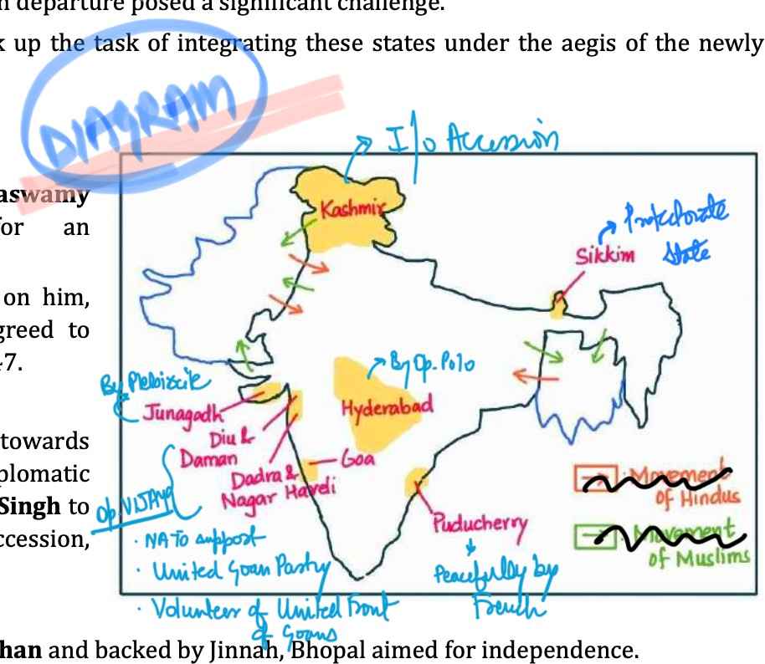In the back drop of partition, the integration and consolidation of the territorial boundaries of the nation had assumed supreme importance. Government was prepared to be flexible in giving autonomy to some of these regions

##### How achieved?

1. **Patel** (charge of state dept with VP menon as secretary) first step - **appeal to the princes to accede** to the Indian Union in **three subjects** imp for **national unity**- Communications, Defence and External Affairs (CDE)
2. Next step - **convince Mountbatten** - in a **speech to chamber of princes**, finally persuaded the Princes
3. **Privy purses**, upholding succession to throne, flying of **personal flags** were used as tools of persuasion
4. States not ready to accede to India where made to sign instrument of accession **through diplomacy**. Ex: **Travancore, Jodhpur, Bhopal**, etc. Ruler of **Kashmir** was made to sign **instrument of accession** before offering any military assistance
5. People organised a popular movement in Junagadh, forced the Nawab to flee and established a provisional government. Indian troops thereafter marched into the state. A **plebiscite was held in the Junagadh state** which went overwhelmingly in favour of joining India
6. In case of Hyderabad, Nizam of Hyderabad denied accession to India. A strong peasant struggle and **satyagraha by state congress** had developed in the Telangana region. In 1948, the Indian army moved into **Hyderabad** and **freed it from Razakars and Nizam** control. The operation was called **Operation Polo**

##### (HP - Hyderabad Polo)

1. Other contributions of Sardar Patel:
   1. Reorganised civil services and formed Indian Administrative Service - defended the services despite opposition
   2. Brought back order and peace after the partition, rehab of refugees, restored law and order
   3. **JVP Committee** - ensured Unity of India
   4. Birth anniversary is celebrated as National Unity Day

##### President of Ahmedabad Municipal Corporation - improved city’s infrastructure, drainage

* 1. Lawyer by Profession - he played key **role at the Constituent Assembly**
  2. Visionary for **Cooperative Movement** → allowed various cooperatives such as AMUL to grow

1. **Administrative Issues:** Confusion among Princely states after lapse of paramountcy as many wanted to be independent; Availability of natural resources with PS made them believe they can survive alone plus India thought we need resources to fulfill growth motives; Connectivity issues: How to connect Hyderabad with either Pakistan or Independence; Peasant Protests: Communist led protests by peasants may lead to anarchy just after partition; How to conduct Elections
2. **Socio-Cultural Issues:** J&K Ruler was hindu but people muslim, Similar confusion in Junagarh, Hyderabad); Fear of loss of prestige with the

kings/princes; Cultural differences among people eg: Telugu speaking in Hyderabad

## Consolidation of territories from foreign govts

After the formation of Union of India the **major foreign enclaves were French and Portuguese**. On gaining independence India opened negotiations with them for the transfer of territories.

##### French enclaves

* 1. Integration of French territories was **done peacefully**. After the formation of Union of India, the rising nationalism in the people forced French government to retreat
  2. **In 1954**, the **four enclaves Karaikal, Mahi, Yanam and Puducherry (SF-KMP)** were transferred to the Indian Union and became the Union territory of Pondicherry.

##### Portuguese enclaves

* 1. **Dadra and Nagar Haveli**: Portugal resisted diplomatic solutions and refused to transfer power to Union of India. **Volunteers of United Front of Goans** (Goans playing role in D&NH) occupied Dadra and Nagar Haveli in **1954** and displaced Portuguese rule
  2. **Goa, Daman and Diu**: **Satyagraha and revolts** by Indian nationalists (**Ram Manohar Lohia - Aguada Jail**) were suppressed by Portuguese government. Some **navy men were fired upon by Portuguese**. This threatened India’s global image → In 1961, Nehru in **Operation Vijay** the **Indian Army & Navy** liberated Goa, Daman and Diu **by force**

## Privy Purse

* The Privy purse was a tax free payment made to the royal families of erstwhile princely states as part of their agreements to integrate with India whereby they lost all ruling rights

##### They are allowed to retain certain private property, and given a tax free

**govt allowance in heredity**, measured on the basis of the extent, revenue and potential of the merging state

* + **At the time of accession,** there was **little criticism** of these privileges since integration and consolidation was the primary aim
  + Yet, **hereditary privileges were not consonant** with the **principles of equality (Article 14)** and socio- economic justice laid down in the Constitution of India (Article 39 b/c)
  + Nehru had expressed dissatisfaction over the matter time and again. Post 1967 elections, **Indira Gandhi supported** the demand that the

government should abolish privy purses. **Morarji Desai** called the move morally wrong and **amounting to a breach** of faith with the princes **(It was defeating the nature of welfare state)**

* + In the **1971** election, the Constitution was amended via the **26th AA** to remove legal obstacles for abolition of privy purses

## Reorganization within the country

* Our **national movement** had **promised the linguistic principle** as the basis of formation of states- **Nagpur sessionof Congress in 1920**- language the basis of the reorganisation of provincial congress. Even Gandhi and Tilak supported idea of ling states (**Supported by Nehru Report**) - Provincial committees based on languages
* **After Independence and bitter exp with partition** and Pak creation- leaders felt that carving out states on the basis of language might lead to disruption and disintegration- also will **draw attention away from other social and economic challenges** that the country faced.
* **Nehruji said - 1st things must come 1st and 1st thing is the security and stability of India** (rather than linguistic reorg or other stuff)
* Dhar and JVP commitee **both denied** the need for lingusitic states due to fear of threat to national unity.
* But death of **Potti Sreeramulu** on fast for a separate province of the Telugu people free from Madras state- widespread protests and finally the creation of Andhra Pradesh.(**Vishalandhra movement**) - Andhra made sep state
* Then **Fazl Ali committee**- State Reorg Commission- 14 lingustic states and 6 UT **(via 7th CAA)**, later Bombay too divided into Maha and Guj, PEPSU into Punjab, Haryana and some parts to HP
  + ⭐⭐ **Accepted language as one of the 4** criterias for reorganisation;

But **rejected one state one language** principle

* Other basis of reorganisation
  + **Language did not, however, remain the sole basis of organisation** of states.- **Sikkim** after referendum joined India, **Chattisgarh**- long pending demand since 1920’s for distinct CG identity, large tribal population.

**Jharkhand**- demand since 1930’s due to tribal areas of Chota nagpur and santhals, **Uttarakhand**- 70 yr struggle for people of hilly region and lack of dev also reason for sep state, **Telangana** (State Reorganisation Commission did not recommend Hydrebad state merger with Andhra) in 2014

Linguistic state creation **served** the **following purposes:**

1. **Language gives a mathematical basis for division**. It put an end to fissiparous tendencies that would’ve balkanized the country on the basis of language
2. Led to nurturing and **promotion of the regional language and culture**, the linguistic states also underlined the acceptance of the principle of diversity.
3. Led to better interaction among people of the states and with their democratically elected governments. A linguistically heterogeneous state would have difficulty in **getting messages across both ways (candidate and voters)**
4. Led to better **penetration of power to grass root level**. A non English or non Hindi speaking person can aspire to become a political leader, which was difficult earlier
5. Led to **consolidation of the federal structure**. People realised that it was easy and peaceful to be Hindi-speaking and Indian, **Tamil- speaking and Indian, Gujarati-speaking and Indian**, etc

##### Contrary to Sri Lanka (linguistic disenfranchisement) & Pakistan who rejected diversity, India accepted diversity and maintainted Unity

But **reorganisation did not resolve all the problems** relating to linguistic conflicts: Border disputes, Linguistic chauvinism (Mumbai for Marathi, Hindi debate), Water sharing issues, Even with same language - TG and AP had to be bifurcated

## Bhoodan & Gramdan Movement:

* + Bhoodan was an attempt at land reform, at bringing about the institutional changes in agriculture through a mass movement. Acharya Vinoba Bhave drew upon Gandhian techniques and **ideas of constructive work and trusteeship**. He was to do padyatra to persuade landowners to **donate at least 1/6th of their land** for distribution among landless.
  + Later, by 1955, **the movement took the form of Gramadan implying that all land to be owned collectively**, not individually (idea was to cultivate their land collectively and divide the income)
  + **Successes** (or terming movt. as failure would be an exaggeration)
    - Movement achieved a considerable degree of success, **especially in North India-UP, Bihar** by **receiving over 4 million acres** **(~~not hectares~~) of land** as donation by 1956
    - Movement helped to **reduce the gap between haves and have-nots**
    - One of the very **few attempts to bring reform via voluntary movement**, not by govt. legislation
    - Created favourable atmosphere for political propaganda and agitation for redistribution of land
    - Promoted the **Gandhian the idea of trusteeship** or that all land belonged to God
    - **Moral success -** convincing the rich landlords to donate lands
  + Failures of Bhoodan:
    - **After 1956** movement **lost its momentum**. While nearly ~4 million acres of Bhoodan land was available, **barely 0.65 million acres** was **actually distributed** among 200,000 families
    - Allotting authorities demanded petty money from the poor for recommending their names for allotment
    - **Big landlords donated** those **land** which were **unfit for cultivation**. The objective of many of the landlords to donate their land was to bypass land ceiling act
    - In the **later phase**, **Bhoodan workers** got associated with one or another political parties. Some of them tried to use the Bhoodan organisation as a means to gain political clout and dividends at the time of election
    - The average size of land given was 0.5 to 3 acres which has **resulted in land fragmentation, diseconomies of scale** and disguised unemployment without any noticeable rise in agroproduction
    - **Mere allotment of land is insufficient**. Because landless **farmer also needed** seeds, fertiliser, irrigation, which were not provided and land became useless for farmer which again mostly went back to landlord

##### Failure of non-violent Bhoodan Movt - Led to violent Naxal movements

* + **Limitation of Gramdan?** Gramdan was **successful mainly in** villages **where**

**class differentiation had not yet emerged** and there was little if any disparity in ownership of land or other property. **E.g. Tribal villages.** But **didn’t find**

**cooperation** from other villages **in the plains** or villages near **urban centers**

* + Gramdan movement was considered superior to the Bhoodan movement because: No fragmentation leading to Economies of Scale, All benefit in Gramdan unlike Bhoodan which benefits only land alotee;
  + 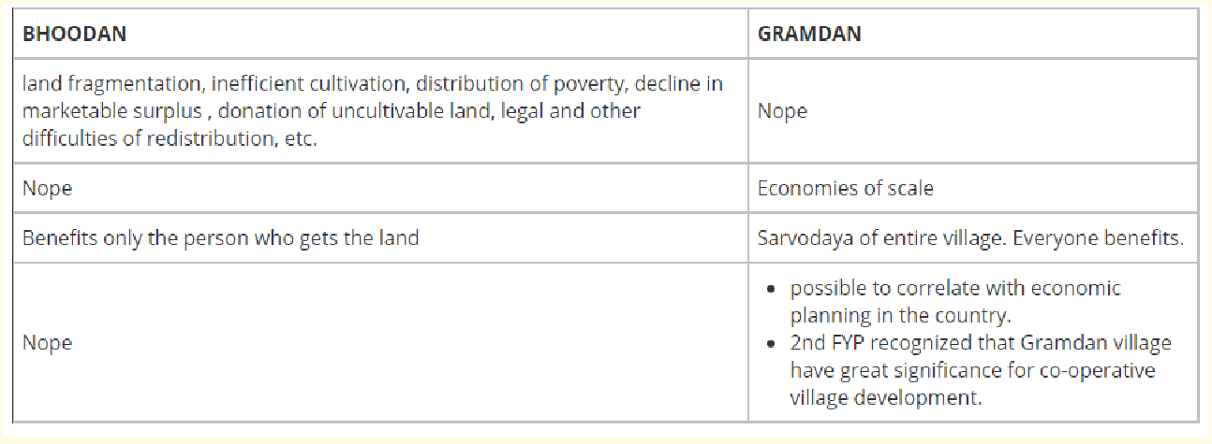
  + Hence it can be concluded about this movement that it was **unique attempt in the history** of free India to bring revolutionary institutional **change, not by law but by mass awareness and participation**. Although it was not fully

successful in its stated objective but its achievement were enormous if weighted against odds.

**Overall: 1947 War** = Karachi Agreement 1949 → **1962 War** = Tashkent Agreement 1965 → **1971 War** = Shimla Agreement 1972

## Tashkent Agreement 1965 (Post India-Pakistan War of 1965)

* + Circumstances:
    - Three weeks of fighting in 1965 has done immense damage to economies of both countries. Apart from loss of life and costly military equipment, resources urgently needed for economic development were drained and defence budgets mounted again
    - The **Tashkent Declaration was a peace agreement between India and Pakistan** after the Indo-Pakistan war of **1965** signed by PM Lal B Shashtri & President Mohd. Ayub Khan. The meeting was was **held at Tashkent, USSR** (now in Uzbekistan). Peace had been achieved by the

intervention of the great powers who pushed the two nations to a cease fire for fears the conflict could escalate and draw in other powers.

* + **Details:** Maintain 1949 ceasefire line in J&K; Withdraw all troops and return to pre war position; Restore trade
    - The Tashkent conference, **under UN, American and Soviet pressure**, compelled India to give away the conquered region in Pakistan and **maintain the 1949 ceasefire line** in Kashmir
    - Both sides agreed to **withdraw from all occupied areas and return to their pre-war August positions**. In the case of India this meant, removing troops from strategic Haji Pir pass, from which Pakistani rangers could enter the Kashmir valley. Similarly Pakistan would have to withdraw from areas captured in Rajasthan
      * Shastri agreed to these unfavourable terms as other option was the resumption of mutually disastrous war and that would also have meant losing USSR support (by not vetoing UNSC sacntions on India) on Kashmir issue in UNSC and in supply of defence equipment, especially MiG planes and medium and heavy tanks.
    - They **agreed to restore economic cooperation and trade** as before. They also agreed to maintain friendly neighbourly relations with each other.
  + **Lessons learnt from 1965 war:** Made pol l’ship mature + Made army stronger for 1971 war + **role of tech built into military doctrine** + India passed first test of secularism (indian muslims supported)
  + **Issues with the agreement**: India had upper hand (could have negotiated J&K for Pak PJ); **No war pact was omitted**
    - The Tashkent Declaration was criticised in India because of the omission of a no-war pact
    - According to some experts since India had a definite upper-hand in the war, it should have not signed the Tashkent Declaration. Instead, it should have used the pressure of having had captured Pakistani Punjab to reclaim its territory in PoK
    - The Pakistan infiltrators failed to generate support from Kashmiris. India’s had **passed its first major test of secularism** as their was no communal trouble and whole hearted support was recd. from the Indian muslims
    - In 1965 Indian commanders were new in handling brigade and division sized forces in battles. The war experience helped in consolidating organisation and leadership. **Strengths and weaknesses of the three divisions of military were understood** and worked upon, which **proved crucial during the 1971 war**.
    - It also **made the Indian political leadership more mature** in dealing with major powers to safeguard India’s interests **diplomatically**.
    - The **role of technology** in the outcome of wars was carefully observed and **built into military doctrines**.
    - The imperative of joint warfare in which the Army, the Navy and the Air Force operated to a cohesive plan towards common objectives became a key ingredient of war plans.
  + But signing the agreement was the wisest decision taken by both the countries keeping in mind that circumstances of those times ,including internationally condemnation, ignoring which perhaps leads to sanctions which was admittedly hard on the eve of ship-to-mouth dependence on wheat aid

## Bangladesh War of Liberation 1971

* + Reasons for resentment among Bengalis?
    - **Pakistan did not recognise democratically elected Govt** of east Pakistan and crushed the peaceful revolt. As a result, **Bengali military, paramilitary and civilians formed the Mukti Bahini** **(liberation army of BG),** which engaged in guerrilla warfare against Pakistani forces **(Sheik Mujibur Rehman)**
    - Bengalis were under-represented in the Pakistan military, bureaucracy and technical posts
    - In 1948, Jinnah declared that Urdu would be the federal language of Pakistan

##### Reasons why India intervened?

* + - **Human Rights violations** committed by the Pakistan army **during**

**Operation Searchlight** (military operation carried out by Pakistan Army **to curb east-Bengali nationalist movement**) in March 1971, which led to the **massacre of ~three million Bengali people**. The campaign of rape, torture and killings, continued for more than six months and pushed about ten million refugees into India.

* + - It is argued that India's military intervention was a way to ensure that the **refugee influx does not become a long-term problem** draining India's resources and debilitating India's poverty alleviation efforts. (number of **refugees reached ~8-10 mn - written above**)
    - The **limited concern shown by** the international community including **United Nations and major world powers** to stop the genocide in East Pakistan, warranted India's military intervention too.
    - It also **posed a security threat to India**. There were apprehensions that owing to the poor living conditions in camps and militarisation of bases around these camps might cause the Bengalis of East Pakistan to engage in rebellion.
    - **Easing of tension** on eastern border could **reduce our expenditure on army on eastern front**
    - It is also argued that **shared ethnic ties with Bengalis** was one of the reasons for **Indians being sympathetic**to their cause despite the heavy economic burden on the Indian economy.
    - It **has** been alleged by some that India's military intervention sought to prevent the people of West Bengal to choose Bengali identity over Indian identity and **cause a division of India for the unification of Bengal**. The ground for such suspicion was the fervour with which people in West Bengal supported the war effort. However, it is difficult to separate such sentiments from the bond arising out of shared ethnicity.

Peace treaty with Soviet : India and USSR moved closer to ink the historic **Indo-Soviet treaty of peace for 20 years to neutralise the effect of the emerging**

**China-USA-Pakistan axis (Consult each other in case of attack or threat by 3rd party → thus provided security umbrella to India)**. Treaty had effectively restrained Pakistan and her allies from embarking on a course of military adventurism in the subcontinent

## Simla Agreement (SA) 1972 aka Suchetgarh Agreement

##### Background:

* + - After the **1st Indo-Pak armed conflict in 1948**, military representatives of both Pakistan and India met in Karachi and signed the Karachi Agreement 1949
    - United Nations Military Observer Group in India and Pakistan

**(UNMOGIP) was meant to supervise the Cease Fire Line (CFL)** established in Jammu and Kashmir in July 1949 **under the Karachi Agreement 1949**

* + - With Bangladesh as a free country, India declared a unilateral ceasefire. Later, the signing of the **‘‘Shimla Agreement’’** between Indira Gandhi and Zulfikar Ali Bhutto on 3 July **1972 formalised the return of peace with Pakistan**
    - Simla Agreement **delineated the ‘line of control’ in** **J&K** which resulted in **CFL being replaced by LoC**(this smart move **made UNMOGIP presence** in Kashmir **irrelevant** as there is no longer a CFL)
  + Reasons why Simla agreement was signed
    - India realised that a **mutually arrived Indo-Pak settlement** was necessary for **durable peace**. A hostile Pakistan would force India to maintain a high level of defence expenditure
    - **Having too harsh conditions** on Pakistan would **weaken the only democratic hope Pakistan** had. From India’s perspective it was much better to deal with their civilian government than to deal with their military
    - **US and UK sent their forces in aid of Pakistan**. By continuing war, India would have to confront a pack of superpowers which was unaffordable
    - **Pakistan was pleading** with the world community and gained **international sympathy**. **India had to release the 90,000 POW to maintain its image** and not to antagonise the world community
  + Terms of Agreement:
    - India **agreed to return the Pakistan territory** it had occupied, **except** some strategic points in Kashmir. Pakistan agreed to respect the existing LoC in Kashmir and undertook **not to after it unilaterally by force or threat of force**
    - The two countries also agreed to **settle all their disputes** through **bilateral negotiations** without any outside mediation by the UN or any other power. Also both countries **accepted the UN charter to govern the 2 countries relationship**
    - India also **agreed to return the prisoners of war** to Pakistan but this was to be contingent upon a Bangladesh-Pakistan agreement
    - The agreement gave **recognition to an independent Bangladesh**

##### Steps to promote trade and commerce, S&T and resumption of postal and telegraphic services

* + Why it was a lost opportunity:
    - Prisoners of war were returned unconditionally to Pakistan
    - India pulled its forces inside the cease fire line of 1965 war
    - India could not persuade Pakistan to accept LoC as international line
    - No permanent resolution of Kashmir issue. There was no explicit mention of Kashmir issue
  + According to Happymon Jacob, **one of shortfall of SA** was that it **did not have rules and norms to enforce the LoC unlike the Karachi Agreement**. Ironically, forces deployed on either side have to resort to the strictures enshrined in the long-defunct Karachi Agreement to observe the ceasefire mandated by the Simla Agreement. This needs to change

## Planning & its impact

* + 💡: Development major challenge post Indep + consensus that dev cannot be left to pvt sector + Planning commission set up (central machinery for planning headed by PM) + Bombay plan by big indus in favour of planned eco + 1st FYP agri/bhakra_nangal dams & land reforms + 2nd FYP/Mahalanobis plan stressed on heavy indus through approach of import substitution→ food shortage as agri outlay was halved; 3rd FYP self reliant/agri focus; Overall first 3FYPs gave avg growth of 7.1% (1951-65)
    - **Major problem that confronted India** immediately after independence was **development**. ‘Development’ was about becoming more ‘modern’ and modern was about becoming more like the industrialised countries of the West
    - Modernisation was also associated with the **ideas of growth, material progress and scientific rationality**and this kind of idea of development allowed for the classification of countries as developed, developing and underdeveloped
    - However, there was a **consensus that development could not be left to private actors**, that there was the need for the government to develop a design or plan for development
    - **Planning commission came into being post indep** with the Prime Minister as its chairperson. It became the **most influential and central machinery** for planning
    - Generally, it is assumed that the big business entrepreneurs are averse to the idea of planning. Contrary to this, a section of **big industrialists came together in 1944** and drafted a joint proposal for **setting up a planned economy** in the country. It was called the **Bombay Plan**
    - 1st FYP **addressed**, mainly, the **agrarian sector including investment in dams and irrigation**, like Bhakra Nangal Dam etc. The plan identified the pattern of land distribution as the principle of obstacle in the way of agricultural growth. Thus **paving way for land reforms**. Basic level of spending was very low in the 1950's. Hence planners sought to push savings up
    - 2nd FYP (**PC Mahalanobis plan**) **stressed on heavy industries**. India was **technologically backward**, so it had to spend precious foreign

exchange to buy technology from the global market. Approach used was

##### import substitution. As industry attracted more investment than agriculture, this led to food shortage

* + - 3rd FYP aimed at making India a '**self-reliant**' and 'self-generating' economy. The **chief priority** of this plan was **agriculture** both to enhance food supply and support the exports and industry
    - **Achievements** of Plans from 1947–65 (**think in terms of PESTEL**)
      * Important achievement in this period was the **rise in the savings and investment rates**
      * **Industry** during the first three plans **grew more rapidly than agriculture**. The industrial growth was based on rapid import substitution
      * Early planners gave utmost priority to the **development of social infrastructure** including education and health
      * Institutions of higher learning particularly in the **scientific field** were set up such as **national laboratories** and institutes, **Atomic Energy Commission**, etc
      * **Abolition of the colonial system of zamindari**, and attempts at consolidation of land
  + **Key controversies regarding 5 year plans -** Agri vs Indus; Public vs Pvt (due to inefficiencies of public led to low growth rate +restrictions on pvt-such as nationalisation); Land reforms did not take effectively; Urban bias; Less focus on social infra
    - **Agriculture vs. Industry**: Indian planners found it difficult to balance between industry and agriculture. Veteran Gandhian economists like **J.C. Kumarappa (cooperative wali committee)** proposed an **alternative blueprint** that put greater emphasis on **rural industrialisation**
    - **Public vs. Private Sector**: Critics argued that the planners refused to provide the private sector with enough space and the stimulus to grow.

The **state controlled more things** than required which led to

##### inefficiency and corruption

* + - The **period from 1967** onwards witnessed many **new restrictions on private industry** eg: Fourteen private banks were nationalised (during Indira Gandhi period). Between 1950 and 1980 the Indian economy grew at a sluggish per annum rate of 3 to 3.5% **(Hindu rate of growth)**
    - **Land reforms did not take place effectively** in most parts of the country; political power remained in the hands of the landowning classes; and big industrialists continued to benefit and thrive while poverty did not reduce much. Those who benefited from unequal development soon became politically powerful and made it even more difficult to move in the desired direction
    - Critics pointed out that the state **did not spend any significant** amount for public **education** and **healthcare**
    - Critics also pointed out that planning was **urban bias**
  + **NEP 1921 by Lenin** and India’s planning post-independence - Lenin shifted to ‘state capitalism’ which was mixed economy + FYP model + Planning Commission + India combined Capitalism & Socialism → These were followed by India

##### NEP - temporarily kept aside complete state control of industries to make way for capitalism - this inspired India’s Mixed economy

* + - NEP sought to infuse some aspects of capitalism into Russian society with what **Lenin termed ‘state capitalism’. State capitalism** referred to adoption of a capitalism oriented economic policy that **introduced a mixed economy**. The state allowed private entities/individuals to engage in small-scale businesses while it controlled major sectors/areas such as banks, foreign trade, defense and some infrastructure-based sectors

##### One of the unique characteristics of the Indian economy

post-independence was the fact that it was a **mixed economy**. India adopted an economic policy that combined aspects **of capitalism and socialism, just like Russia’s NEP** adopted a policy **combining**

##### communism and capitalism.

* + - The NEP also sought to **establish linkages** between the **rural economy and** the **urban economy.** In India, the emphasis was on establishing

linkages between the relatively developed urban areas and the painfully backward rural areas

* + - As in the USSR, the **planning commission** of india **opted for** five year plans **(FYPs)**
  + **GROWTH RATE** - was 7% in first3 FYP (1951-65), but overall pre 1991 it was Hindu Growth Rate of 3.5%

##### Although the National Emergency of 1975 was a temporary setback in independent India's history, it bolstered the spirit and resistance of our democracy. Discuss

* + - Introd: NE 1975 **for 21m**, **reasons cited were national security** but others such as **tussle with judiciary** and total revolution by **JP Narain**
    - Temporary Blip: **Press censorship**; HR Violation (**forced sterlization**), State led excesses such as **preventive detention**; FR were suspended/Protests banned; **42nd AA brought** during emergency; **RSS/Jamaat-e-Islami were banned**
    - Bolstered spirit: **44AA** (**armed rebellion, written recom of cabinet**, Article 20/21 cannot be suspended), **Condition for approval of advisory board after 3m introduced for preventive detention**, **Judiciary**

**(enlarged Article 21** and reinforced BSD, **Collegium system** to safeguard independence)

## Punjab Crisis

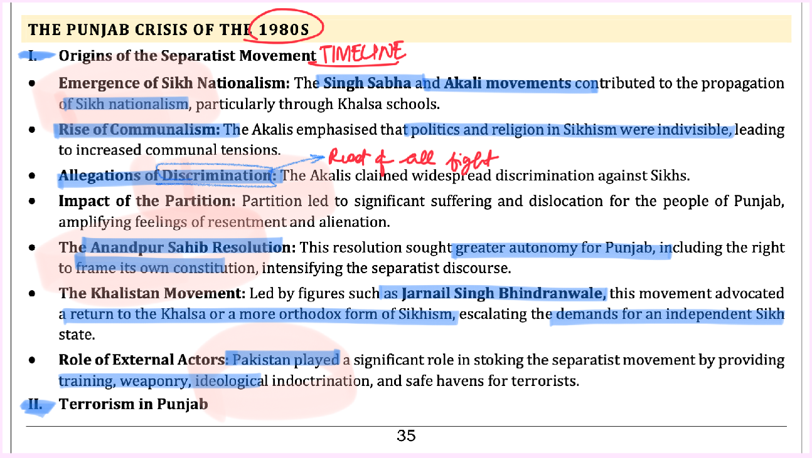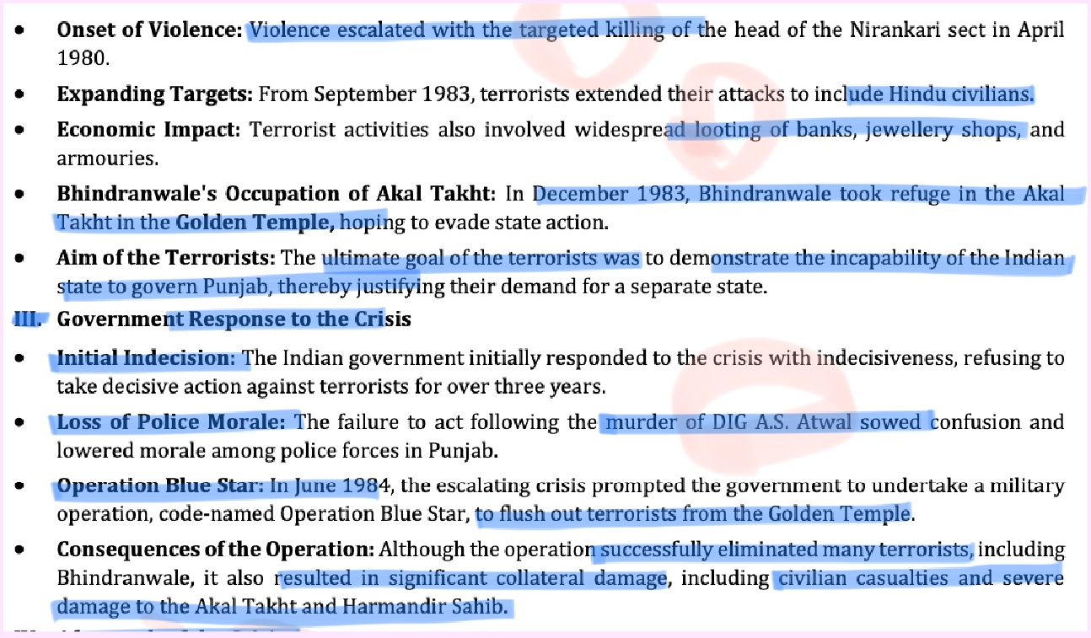

* + 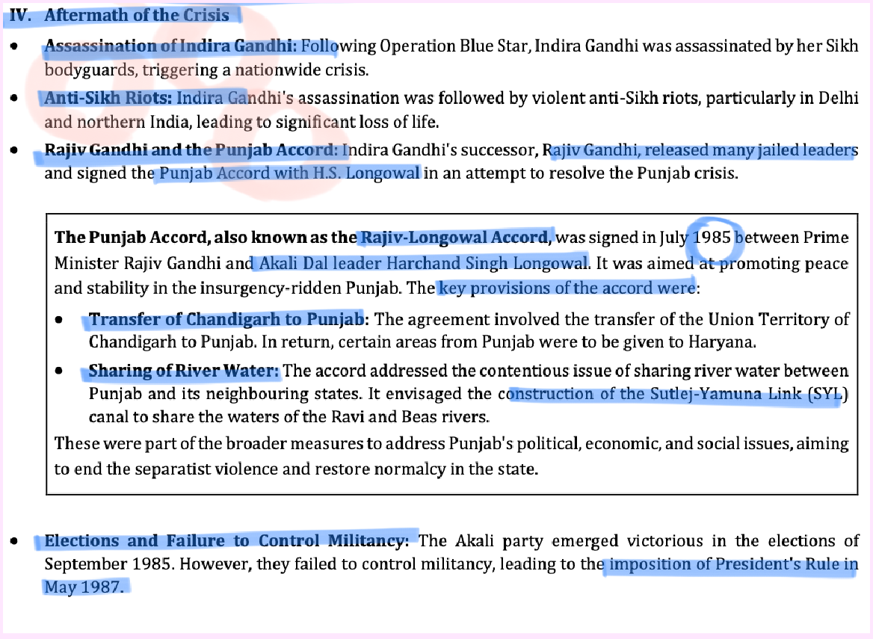

### Other themes from Test Series

##### Q: Farmer movements have been major political movements which leave a huge impact on the politics of the time. Discuss in terms of evolution of farmers movements in post-independence India. (10 marks)

* + Ans. Farmers movements in Independent India have been centers of social as well as political mobilization. As observed in the recent farm protests, these movements leave a huge impact on the politics of the time.

##### Evolution of Farmers protests in Independent India:

* + - * 1. First phase (1947-1960)- i. Centered around anti feudal sentiments, resentment against landlords and exploitation of workers. Ex: Tebhaga (1946-49), Telangana movement (1946-51). ii. Land reform movements such as Bhoodan, Gramdan movements.
      * 2. Second phase (1960-1990) i. Green revolution and commercialization of agriculture in the 1960s. ii. Rich farmers who benefited from the green revolution led the movements. iii. Ex: Farmers movements led by rich farmers in Gujarat, Maharashtra, Karnataka etc.
      * 3. Third phase (1990 onwards) i.With economic reforms, rise in “New Farmers Movements”. It employed new methods, new goals and new ideas. Ex: Constitutional methods of Dharna and

agitationsbecame the norm. ii. No attachment to romanticized rural life, but **demands of better opportunities**, development and modernization of villages.

* + - * 4. Immediate phase: Demands of **MSP raise, loan waiver** (rather than structural reforms into agriculture)
    - Impact on the politics of the time
      * 1. Manifestations of underlying grievances- Public participation because of larger grievances and the government forced to address those grievances.
      * 2. Political participation of farmer leaders- The leaders leading the protest open join active politics and thus become the public representatives.
      * 3. Social issues taken- Ex: Maharashtra movement under Shetkari Sangathan took the cause of women.
      * 4. Offer support to political parties- These movements oen have political support which they give back in form of votes and backing.
    - Conclusion: The farmers movements have brought a paradigm shift in the discourse and perception about farmers in India. This shift is clear in the form of consequences these movements have had which has also le an impact on the socio-political condition of the times.

##### Q: “Nationalization of banks in post-independent India had far reaching social, economic and political consequences”. How far do you agree with the statement? (15 marks)

* + - For stable economy we need strong banking sector; Nationalisation of 1960s & 1980s is considered as the single most important economic step in the history of India
    - Social consequences: Banks penetration, **Targeted growth through PSL**, Differential rates for weaker section
    - Economic consequence: **economic activity in the country increased, household savings increased**, Increased growth output and jobs market
    - Political consequences: Implementation of government schemes eg: PF, Pensions; **Socialistic ideals could be promoted**
    - Limitations of Bank Nationalization: Large population still remained out of the banking system eg: tribal areas of CG/JH; Narsimhan committee report in 1991 pointed out the management weaknesses and political pressures which led to inefficient functioning of banks; Uncompetitive w/o private sector
    - Conclusion: Nationalisation was much needed at that time. In **today’s scenario what we need is bank recap, top banks in 100, etc**